Guidance for SD Refund of Col Centre Code :

1. To process SD refund of CC go to **Manage** -> **Collection Centre**  -> **SD refund Details .**

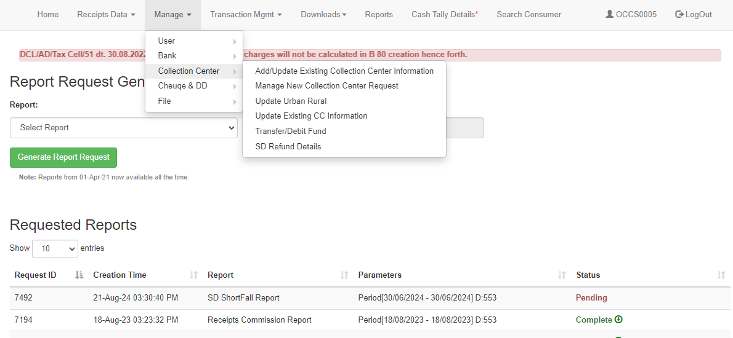

2. Enter the deactivated/closed collection counter to view the information.

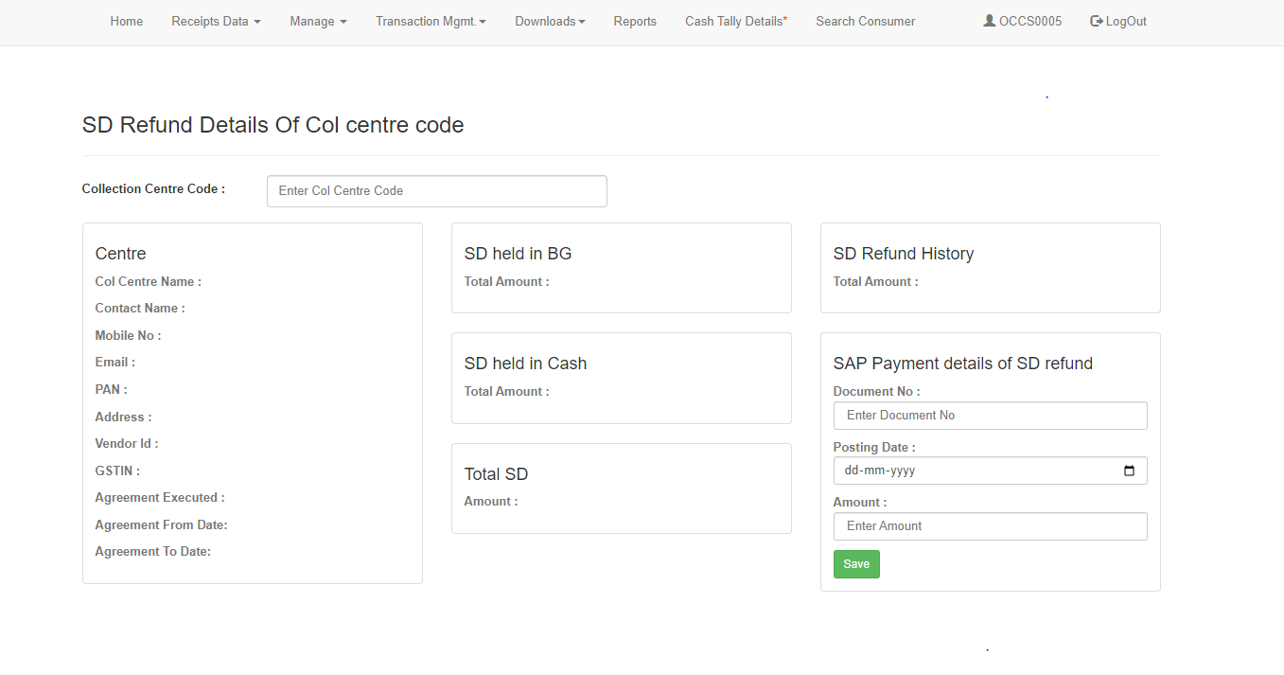

3. The details of the collection centre will be displayed. If there is an SD amount currently held (in BG/Cash) or if a refunded amount is present in the SD refund history, click on the **View Details** button to see the SD amount details.

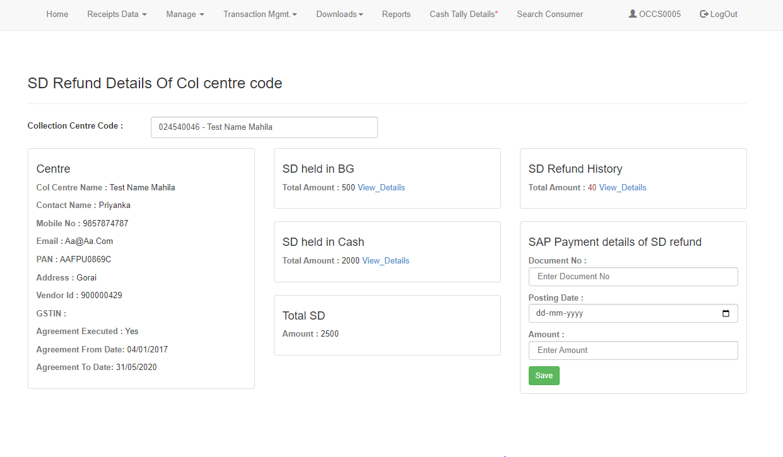

4. After clicking on **View Details** for the BG, the details of the SD amount held in the BG will be displayed.

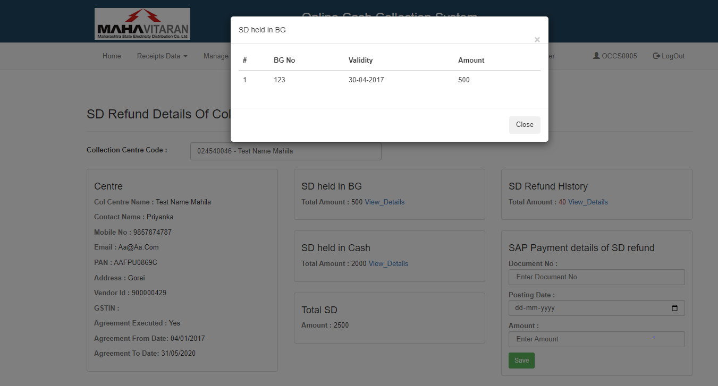

5. After clicking on **View Details** for Cash, the details of the SD amount held in Cash will be displayed.

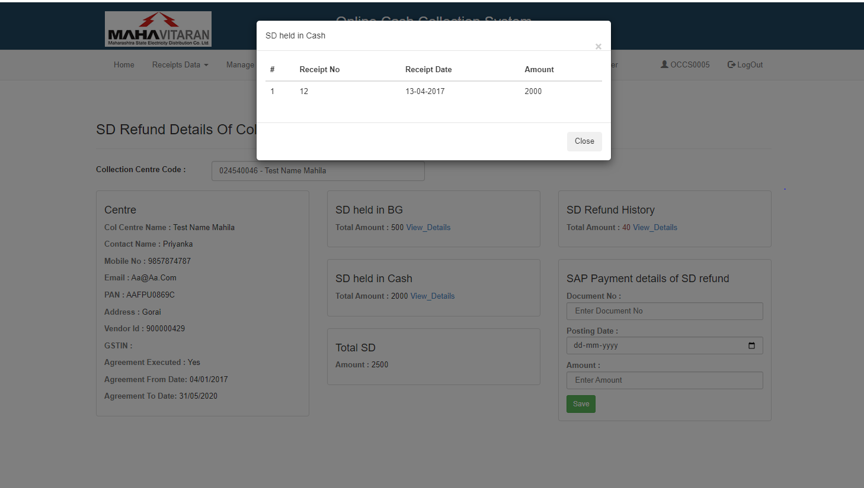

6. After clicking on **View Details** for Refund History, the details of the SD refunded amount will be displayed.

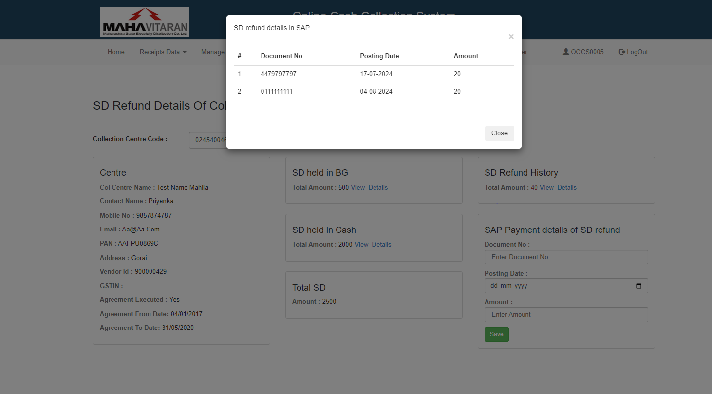

7. In the SAP payment details for the SD refund, enter the **Document No**, **Posting Date**, and **Amount**, then save your entries.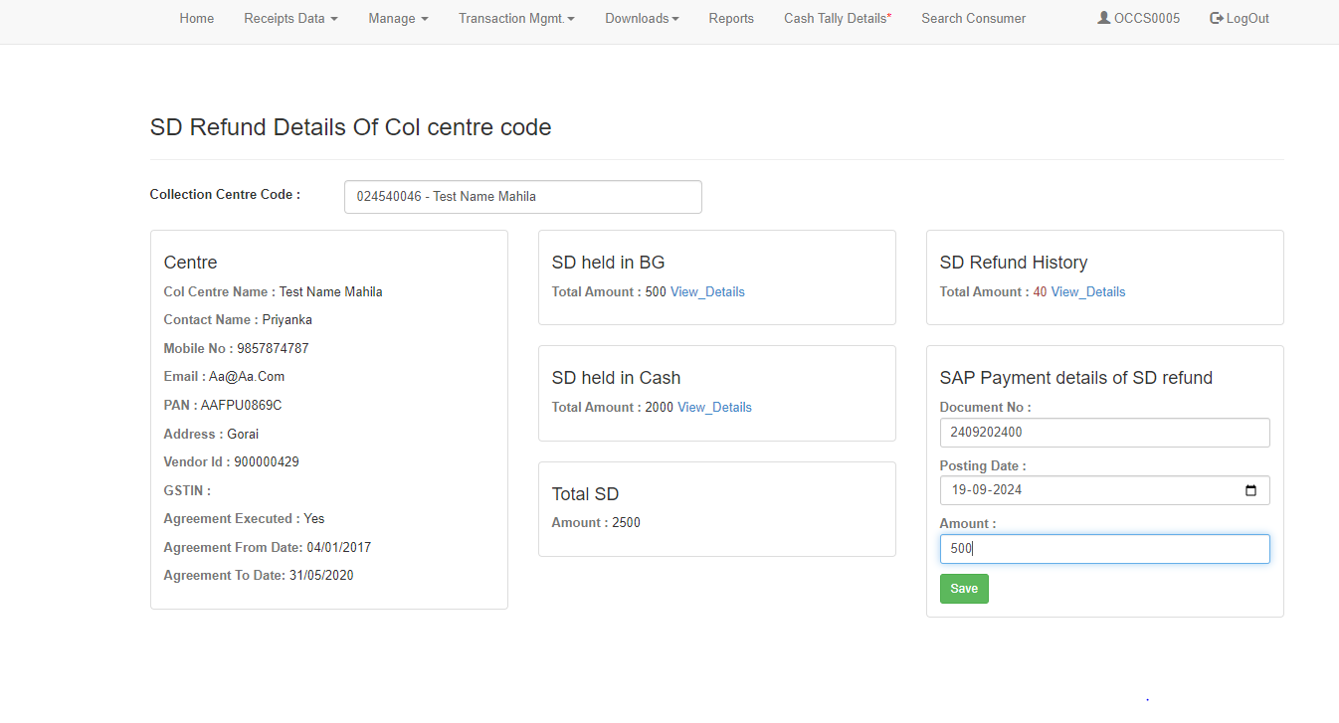

8. A message stating "Data saved successfully" will be displayed upon successful submission.

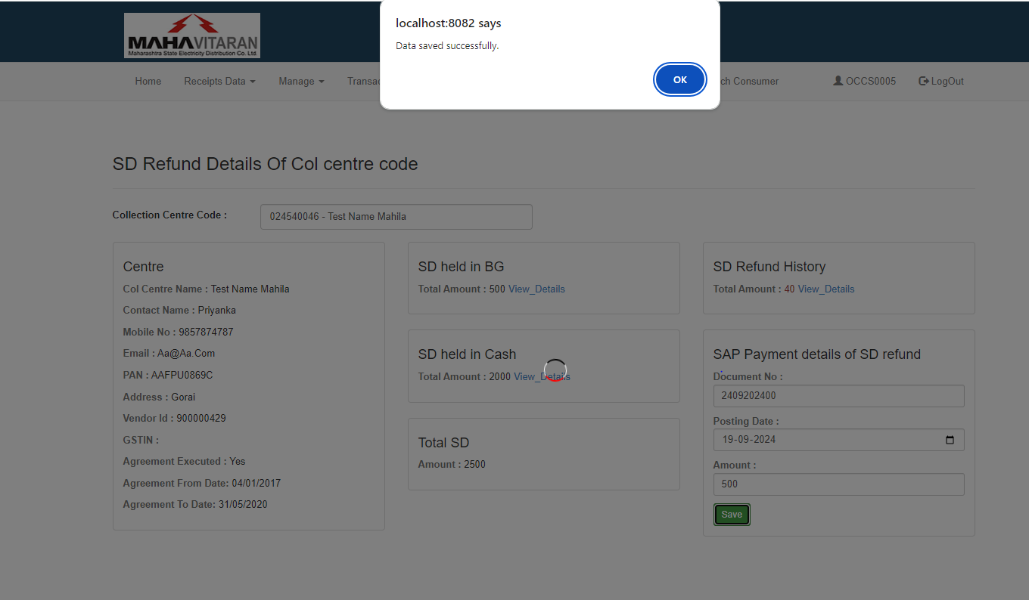

9. The Security Deposit Refund Details report is also available in the Detail Report section..

